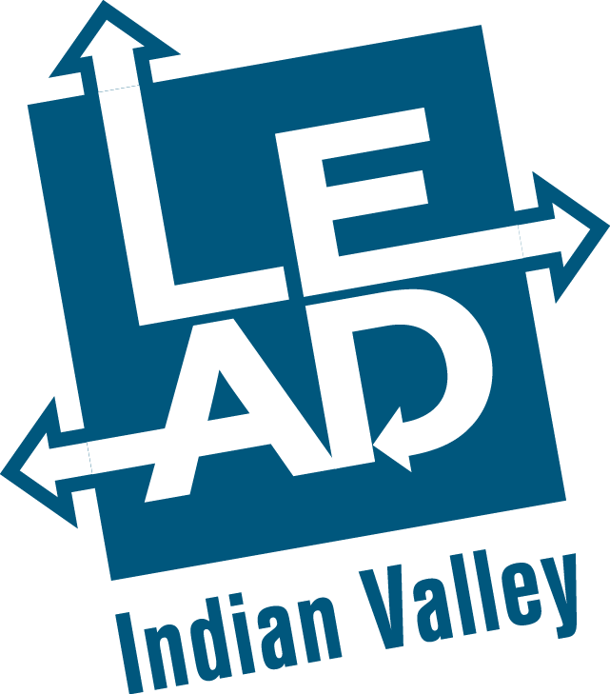

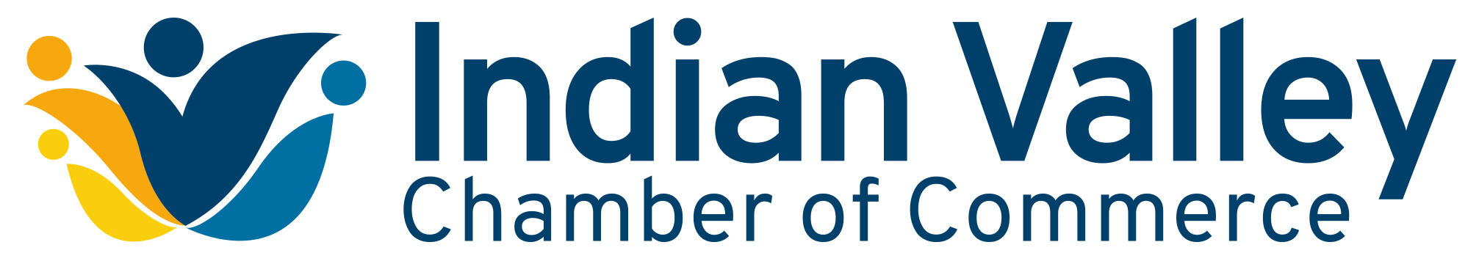

LEADERSHIP • EXPLORATION • ADVANCEMENT • DEVELOPMENT

What is LEAD Indian Valley?

Designed for business and nonprofit executives or emerging leaders, the LEAD IV curriculum has a specific emphasis on developing self-awareness and identifying the skills needed to successfully lead teams.

The Chamber is committed to preparing future leaders who can effectively manage the growing diversity in our local communities and workplaces. We respectfully invite you to identify persons in your organization who would be candidates for this program.

A limited number of sponsorship opportunities are available, some of which offer tuition discounts. Contact the Chamber office for details.

Since its inaugural year (2016-17) the program graduated 76 participants.

How do I apply?

Provide the following item:

- Completed application form, signed by both applicant and employer/sponsor.
Document must be submitted by Friday, August 6, 2021 to:

Indian Valley Chamber of Commerce
ATTN: LEAD Indian Valley Program
121 E. Chestnut Street, Ste. 201
Souderton, PA 18964

TUITION

Tuition is due within one month after notification of acceptance to the program:
- Chamber Members - tuition is $1,050
- Non-chamber Member - tuition is $1,650, a $100 discount is applied if paid by August 6, 2021.

Please make checks payable to Indian Valley Chamber of Commerce, with LEAD Indian Valley in the memo. The tuition includes all program fees (classes and materials).

EXPECTATIONS

Class participants of the LEAD Indian Valley Program are expected to commit the necessary time to fully participate in the program. Full participation includes:

- Regular attendance (only two missed session permitted to graduate).
- Preparation for sessions by completing reading and class assignments, including a company project.
- Active participation in class sessions.

SCHEDULE
The program begins in September 2021 and concludes in May 2022. Sessions are held the 2nd Friday of each month from 8:30 a.m. to 12:30 p.m. Session 1 is a full day.
Date | Title | Content
Session 1  9-10-21  (full day) | Program Launch  Understanding Your Leadership Approach | Opening reception; Introductions; Orientation to the program; Develop program expectations and Class Ground Rules; Everything DiSC Work of Leaders® – Part 1 (Introduction and Vision modules); Lunch; Area bus tour; Set up interviews with community leaders.  Take home: Community Leader Interview Guide.
Session 2  10-8-21 | Understanding Your Leadership Approach | Introduction to the Everything DiSC Work of Leaders® – Part 2 (Alignment, Execution, & Action Planning modules). Take home: WOL Book; Online assessment for the Team Dimensions® profile.
Session 3  11-12-21 | Project Team Leadership – Company Project Launch | Use Team Dimensions® profile to identify basic team roles. Learn the “Z-Process” for project management. Take home: Online assessment for the Personal Listening Profile®. Begin planning your internal company/organization project.
Session 4  12-10-21 | Enhancing Your  Listening Skills | Use Personal Listening Profile® to identify natural listening approach and its strengths and challenges. Explore the role of listening in communication effectiveness. Recognize and use effective approaches for different listening situations. Work on your company/organization project.
Session 5  1-14-22 | Change  Management | Guest facilitator: Helene Matthews, M.Ed., PMP, US Training Manager for Almac Group will present “Planning for Change.” Making change happen in your organization takes time, planning, and leadership. Develop the plan you need to manage change effectively. Understand the fundamentals of change management. Take the first steps in developing a plan to manage the change needed to make your company project successful. Work on your company/organization project. Take Home: StrengthsFinder 2.0 book; Online assessment for StrengthsFinder.
Session 6  2-11-22 | Strengths-Based  Leadership | Mentor Breakfast Strengths theory. Your five signature themes and their relationship with each other. How to nurture your themes into strengths. Applying your strengths in various leadership roles. Work on your company/organization project. Take home: Online assessment for the Everything DiSC® Productive Conflict profile.
Session 7  3-11-22 | Harness the Power of Productive Conflict | Learn ways to improve self-awareness around conflict behaviors. Introduction to the Everything DiSC® Productive Conflict profile. Understand how to manage your response to conflict situations. Discover communication strategies for engaging in productive conflict with colleagues. Work on your company/organization project.
Session 8  4-8-22 | Nonprofit Board  Leadership | Meet local nonprofit executives and explore the issues they are facing. Learn how to be an effective on profit board member. Work on your company/organization project.
Session 9  5-13-22 | Leadership Legacy and Company Project Presentations | Creating a leadership legacy. Report on your company/ organization project. Program evaluation.
May Date  to Be Determined | Graduation Luncheon | Chamber hosted graduation luncheon celebration with speakers, guests, sponsors and supports, mentors, and alumni.
Ongoing | Company/Organization  Project | Each participant will select a project they plan to implement and oversee within their sponsoring organization. Project reports will be due in May and must show how participants used what they learned during class to successfully design and execute the project.

QUESTIONS?

Contact Ken Byler, Program Director
Phone: 215-799-1216
Email: ken@highergroundcg.com

